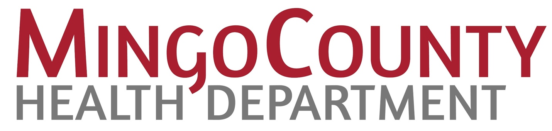

**Registered Nurse (RN) - Public Health Department Job Description**

**Position Title**: Registered Nurse (RN)  
**Department**: Public Health  
**Reports To**: Health Department Administrator / Director of Public Health  
**Location**: Mingo County Health Department 101 Logan St. Williamson, WV 25661  
**FLSA Status**: Exempt  
**Status:** Full-Time Position – May consider Part-Time or Temporary Status  
**Salary**: $45,000 to $55,000

**Job Summary:**

The Registered Nurse (RN) in the Public Health Department plays a critical role in promoting the health and well-being of communities. This position involves providing direct clinical services, health education, disease prevention, and health promotion in a public health context. The RN will assess, educate, and advocate for individuals and families, collaborate with multidisciplinary teams, and contribute to public health initiatives to reduce health disparities, improve community health outcomes, and ensure access to care.

**Key Responsibilities:**

**Clinical Nursing Services:**

* Provide nursing assessments, interventions, and care in community settings, including homes, schools, clinics, and other public health facilities.
* Conduct screenings, immunizations, and health risk assessments for various diseases and conditions.
* Administer and educate clients on medications, vaccines, and other preventive treatments.
* Provide wound care, chronic disease management, and follow-up care for patients in the community.
* Monitor patient health and progress and collaborate with other healthcare professionals for referrals and ongoing care.
* Participate and work with the Substance Use Disorder (SUD) Team

**Health Education & Promotion:**

* Develop and deliver health education materials and programs to individuals, families, and community groups on topics such as nutrition, disease prevention, maternal and child health, and substance abuse prevention.
* Promote health literacy and empower community members to make informed decisions about their health and well-being.
* Work with schools, workplaces, and community organizations to implement health promotion programs that meet the needs of diverse populations.

**Disease Prevention & Control:**

* Participate in the planning and implementation of public health initiatives for disease prevention, including vaccination campaigns, screenings, and health surveillance.
* Monitor and report trends in communicable diseases, working with local and state health authorities to prevent outbreaks.
* Conduct case investigations and follow-up for communicable diseases, ensuring appropriate care and isolation protocols are followed.
* Educate clients on prevention and self-care strategies for managing chronic illnesses and communicable diseases.

**Collaboration & Community Outreach:**

* Work closely with public health teams, community organizations, local healthcare providers, and government agencies to identify and address public health needs.
* Engage with community members and stakeholders to assess health risks and resources, creating strategies for improving public health in the community.
* Advocate for health equity and work to eliminate health disparities by ensuring access to health services for underserved populations.

**Recordkeeping & Reporting:**

* Maintain accurate and up-to-date records of patient encounters, treatments, and progress in accordance with state and federal regulations.
* Prepare reports on community health trends, disease surveillance data, and public health program outcomes.
* Ensure compliance with documentation standards and quality assurance protocols.

**Emergency Preparedness & Response:**

* Participate in emergency preparedness and disaster response efforts, including mass vaccination clinics, disease outbreak containment, and other community health crises.
* Collaborate with public health and emergency management teams to ensure coordinated and effective response to public health emergencies.

**Required Qualifications:**

* **Education**:
  + Associate’s or Bachelor's Degree in Nursing (ADN or BSN) from an accredited nursing program.
* **Licensure/Certification**:
  + Current and valid Registered Nurse (RN) license in the state of [State].
  + Certification in CPR and First Aid required (BLS preferred).
  + Public Health Nurse Certification (PHN) or other relevant certifications may be preferred or required depending on local regulations.
* **Experience**:
  + At least [1-3] years of nursing experience, with a preference for experience in public health nursing, community health, or clinical settings.
  + Experience in health education, disease prevention, or working with diverse populations is highly preferred.

**Skills and Abilities:**

* Strong knowledge of public health nursing principles, practices, and policies.
* Ability to assess and evaluate the health needs of individuals and communities.
* Skilled in providing health education and delivering community-based care.
* Excellent communication, interpersonal, and cultural competency skills.
* Ability to work effectively both independently and as part of a multidisciplinary team.
* Knowledge of local, state, and federal health regulations and public health policies.
* Strong organizational and time-management skills.
* Ability to use electronic health records (EHR) and other healthcare technology systems.

**Physical and Environmental Requirements:**

* Ability to perform nursing duties in a variety of settings, including clients' homes, schools, clinics, and community centers.
* Must be able to lift, carry, and/or move equipment and supplies up to [X] pounds.
* Frequent travel within the community may be required (mileage reimbursement may be available).
* Ability to work in varied environmental conditions, including occasional exposure to health risks, hazardous materials, and disease outbreaks.

**Work Environment:**

* The RN will primarily work in community-based settings, which may include homes, schools, clinics, public health agencies, and health fairs.
* Work hours may include evenings or weekends based on program needs or emergencies.

**Application Instructions:**

To apply, please submit a resume and cover letter to [contact details], outlining your qualifications and interest in the position. Applications are accepted until [closing date].

**Mingo County Health Department is an Equal Opportunity Employer. We encourage applicants from diverse backgrounds to apply.**